1. Can we also have these fields filled out already, when they were filled out in the profile section:

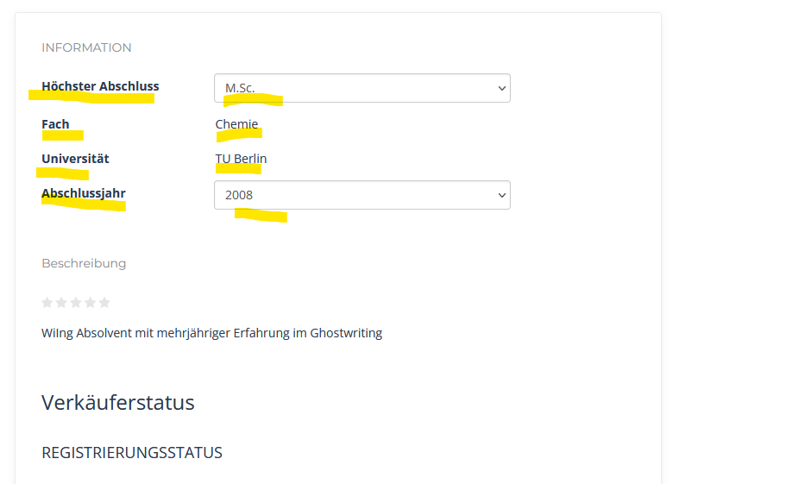

1. Can we also have “Beschreibung” and “Budget” Prefilled?

